Table of Contents
1. Introduction 2
1.1. Existing System 2
1.2. Need for the New System 2
1.3. Objective of the New System 3
1.4. Problem Definition 3
1.5. Core Components 3
1.6. Project Profile 3
1.7. Assumptions and Constraints 3
1.8. Advantages and Limitations of the Proposed System 3
1.9. Proposed Time Line Chart 3
2. Requirement Determination & Analysis 3
2.1. Requirement Determination 3
2.2. Targeted Users 3
3. System Design 3
3.1. Use Case Diagram 3
3.2. Class Diagram 4
3.3. Interaction Diagram 5
3.4. Activity Diagram 7
3.5. Data Dictionary 8
4. Development 9
4.1. Coding Standards 9
5. Agile Documentation 9
5.1. Agile Project Charter 9
5.2. AGILE Road Map 10
5.3. Agile Project Plan 10
UI Designing 11
Email and Password verification 11
5.4. Agile User Story ( Minimum 3 Tasks) 11
5.5. Agile Release Plan 11
UI Designing 11
Email and Password verification 11
5.6. Agile Sprint Backlog 11
UI Designing 12
High 12
Complete 12
8 12
Email and Password Verification 12
High 12
Complete 12
8 12
5.7. Agile Test Plan 12
19-08-2020 12
Expected Result 12
Actual Result 12
Pass 12
Yes 12
No 12
Yes 12
Yes 12
Yes 12
5.8. Earned-value and burn charts 13
6. Proposed Enhancements 13
7. Conclusion 13
8. Bibliography 13

Introduction
The analysis, design and development details of Portify (automated portfolio generator) are presented here in this document. This document will detail the problem to be solved, requirements for solution, system design, and functional operation of the proposed system.
An online portfolio has become a necessity for students, developers, and professionals to display their work, skills, and accomplishments in the digital world today. Unfortunately, creating an online portfolio usually requires knowledge of web development tools such as HTML, CSS, JavaScript, and hosting sites. Many users have encountered issues while trying to develop and maintain a professional portfolio.
With Portify, users have the ability to create a portfolio with pre-built templates, enter their own information, generate professional content (using AI), view a completed portfolio and download instantly through a web-based application.

Existing System
Today, users build portfolios by:
- Building and developing HTML / CSS websites from scratch (manual)
- Using limited function website builders
- Creating static PDF resumes
The workflow of the current system consists of:
- A user sketches out their own layout
- A user types in their HTML and CSS code
- A user uploads their files to a web host
- A user will manually update their content (when needed)
Problems with the Current System:
- Requires technical skills
- Can be time intensive.
- Difficult to maintain
- Limited automation
- No AI included

Need for New System
Novice and non-technical users lack adequate methods for making portfolios with current methods available to them. Students and professionals prefer that they can easily create their portfolio without knowledge of web development in the most efficient time possible.
The need for an alternative system arises because of the following:
- There are no reliable/simple ways to create portfolios as a generator
- There is too much time spent on designing & developing
- Websites are complex to maintain/change/update.
- There is a need to ensure that the content of the portfolio is created by automation.
Portify solves these issues by automating processes, providing templates, and using AI to assist in the creation of portfolios.

Objective of New System
Portify aims to do the following:
- Make it easier for users to create a portfolio.
- Provide users with professionally designed pre-made portfolio templates.
- Allow users to view their portfolio before they download it.
- Create a "About Me" page using artificial intelligence.
- Enable users to easily download their completed portfolio file.
- Make it easier for administrators to manage their portfolio template and user accounts.

Problem Definition
Numerous college and professional individuals lack both the technical staff and enough time to develop an online professional portfolio website capable of providing them with an outlet for showcasing their skills. The intent of this project is to develop an online application that will allow a user to create a web-based portfolio with no technical knowledge by using pre-scripted templates and dynamically generated forms.
Through the system, users will be able to sign up for an account, select a pre-made template, input the relevant information regarding their professional experience, view the completed portfolio before creating it, and download all of the generated portfolio documents from the website.

Core Components
This proposed system will include the following components:
- Authentication Module
  - Registration and Login Options
  - Roles Based Access - Administrator / User

- Templates Module
  - Administrator can add a template
  - Administrator can update or delete a template
  - User access to view templates

- Portfolio Creation Module
  - Dynamic form to input information.
  - Ability to save portfolio information.

- AI Content Generation Module
  - Ability to automatically create an "About Me" section.

- Preview Module
  - Ability to view a "live" portfolio.

- Download Module
  - Generate Portfolio Files
  - Ability to Download ZIP

- Administration Panel
  - Manage Templates
  - Manage Users
  - View Statistics

Project Profile
Project Name: | Portify – Automated Portfolio Generator
Project Type: | Web Application
Technology Used: | ASP.NET MVC Framework
Database: | SQL Server Management Studio 21
Frontend: | HTML, CSS, JavaScript
Backend: | C#
AI Integration: | Gemini API

Assumptions and Constraints
Assumptions
- It is assumed that users will have access to the Internet.
- It is assumed that users will provide valid information.
- It is assumed that the server and database are available.
Constraints
- The availability of APIs affects AI features.
- The number of portfolio templates available will initially be limited.
- Internet connectivity must be available.

Advantages and Limitations of The Proposed System
Advantages
- User-Friendly
- Time-Efficient
- No Coding Required
- Professional Designs
- AI Generated Content
- Rapid Downloads & Sharing
Limitations
- Requires Internet Connection
- Version 1.0 has Limited Templates
- AI Content Requires Editing to Your Liking

Requirement Determination & Analysis

Requirement Determination
To identify the needs for this project, several different options were considered:
- Discussions were held with project guides.
- Comparable portfolio platforms were researched.
- Issues frequently encountered by other students were noted.
- Many features were discussed at length in brainstorming sessions.

Targeted Users
1. Students
As one of the main user groups of the system, students are able to:
- Set up their own portfolio for placement purposes
- Display the academic projects they have done and internships they have completed
- Exhibit their technical abilities or soft skills
- Include certification(s) and other accomplishments
- Share their portfolio link with recruiters
2. Developers
There are many ways that developers can use the system. They can:
- Showcase personal and professional projects
- Exhibit the programming language(s) they know and the technologies they can use
- Add links to their GitHub or other project(s)
- Share their portfolio link on their résumé or job application
- Keep their online profile updated
3. Designers
Designers can also utilize the system by doing the following:
- Showcase their creative work and samples of their designs
- Exhibit their UI/UX projects and case studies
- Present their visual portfolios in a professional manner
- Share their portfolios with their clients or companies
4. Job Seekers/Professionals
Individuals searching for a job are able to do the following using the system:
- Create a personal portfolio website relatively quickly
- Highlight their work history or what skills they possess
- Share the link to their portfolio with their interviewer in an interview
- Keep an online professional presence

5. Freelancers
Freelancers can apply the system by doing the following:
- Showcase their previous client projects
- Present their services and skills
- Share their portfolio link with potential clients
- Build their credibility through an online presence
6. Admin
The admin is responsible for managing the system. The admin is able to do:
- Manage the templates (e.g., adding, editing, deleting)
- Manage the users of the system
- Monitor how the system is used and track the statistics
- Maintain the data and functionality of the system.

System Design

3.1 Use Case Diagram (Explanation)
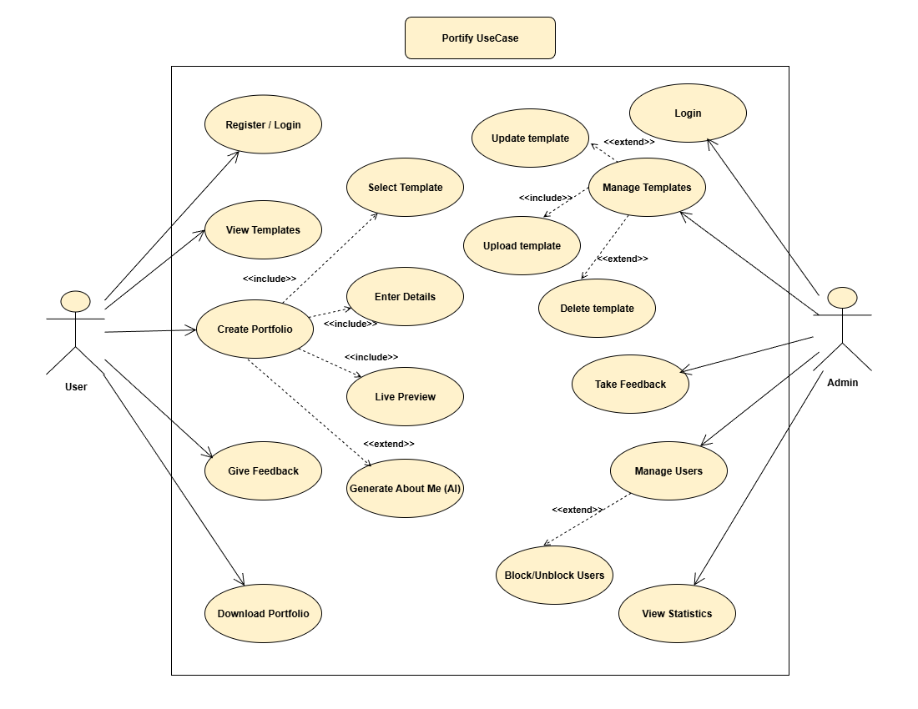

The Use Case Diagram represents the interaction between users and the Portify system. It shows the different functionalities available to each actor and how they interact with the system.

Actors in the System
There are two types of actors who can interact with the system: the user and the admin. Users are people who access the system to create and edit their own portfolios, while admins are responsible for maintaining the system and helping users with issues related to their portfolios.

1.Users will:
- Register for an account
- Login to their account
- Browse through available templates
- Select a template(s) to use in their portfolio
- Provide information about themselves and their projects
- Use AI to create an "About Me" page
- View their portfolio in real-time
- Download their completed portfolio
- Provide feedback about the system and templates
The two actions of Providing Information and Viewing Portfolio in Real Time are necessary to the Portfolio Creation use case.

2.Admin will:
- Login to their account
- Upload/update/delete templates
- Create/manage users
- Block/unblock users if needed
- View statistics for the system
- Read feedback left by users
The actions of Upload Template, Update Template, and Delete Template are extensions of the Manage Template use case.

System Boundary
The rectangle in the diagram represents the Portify System, which contains all functionalities such as portfolio creation, template management, feedback handling, and statistics monitoring.

Relationships Used

Include Relationship (<<include>>)
Used for functions that must be part of other functions.
Example:
- Create Portfolio includes Enter Details and Live Preview.
Extend Relationship (<<extend>>)
Used where a function is optional or an extension of another function.
Example:
- Generate About Me (AI) extends portfolio creation.
- Upload/Update/Delete Template extend Manage Templates.

